States of Matter:

Matter Always Matters
Judy Rosenbaum
Stone, as solid as can be,
Can't fit in a smaller place.
Water (liquid) from a lake or sea
Takes the shape of any space.
But the gases of the air
Can't be seen by human eyes.
They can slip in anywhere
Change to any shape or size.

Solids | Liquids | Gases
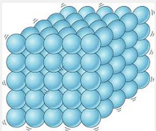 | 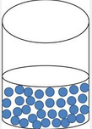 | 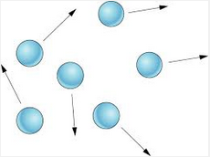
Particles close together. | Particles have spaces between them | Particles spread out
Does not flow | Flows and takes the shape of the container | Flows and fills the container
Lowest energy | More energy than solids | Highest energy

